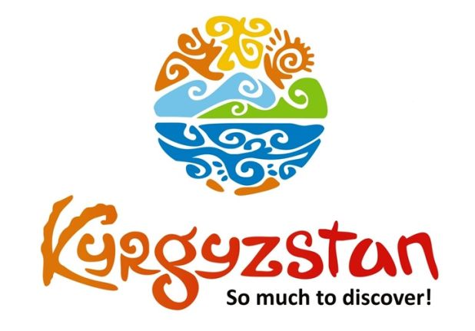**Kyrgyz treatment in Suusamyr Valley**

Country: **Kyrgyzstan**

Period: **May - July**

**Days: 6 / Nights: 5**

Organizing any complexity of tours to Issyk-Kul, Son-Kul, around Kyrgyzstan and Central Asia. We guarantee you high quality of service and individual approach!

The mares milk at high altitudes contains dozens of valuable micro elements that could serve as a treatment for enriching one's health. Kymyz therapy gains the popularity among local Kyrgyz people and foreigners year by year.

The Kymyz Treatment complex ["Baytur"](https://www.youtube.com/watch?v=gR0C7u_Wp9I) is located high in the mountains (2200 m) at Suusamyr Valley. The complex was established in 2011 and since then it became one of the best places for not only drinking kymyz, but also enjoying the beautiful untouched nature and fresh air.

#### [Day 1: Manas Airport – Suusamyr Valley (160 km/~3 h)](https://concept.kg/en/tours/inbounds/29/#program_collapse_142)

#### 

Upon arrival to airport, meet with a driver and depart to Suusamyr Valley.   
On the way drive through Too-Ashuu Pass (3586m).  
Suusamyr is the natural treasure of Inner Tien-Shan Mountains. It is located between the ridges of Kyrgyz and Talas Ala-Too. The valley is situated at the altitude of 2000-3200 m and has an extension of about 155 km.  
Suusamyr valley is famous for its pastures. The valley attracts mountain climbers, skiers and tourists who just want to spend time in fresh mountain air.  
Arrival and accommodation at Baytur Complex.  
Dinner and overnight.

Meals: lunch, dinner

#### [Day 2: Suusamyr Valley – Chychkan Gorge (122 km/~2 h)](https://concept.kg/en/tours/inbounds/29/#program_collapse_143)

#### 

One day excursion to Chychkan Gorge.  
Lunch at a roadside café or picnic lunch.  
Return back to the complex in the afternoon.  
Dinner and overnight.

Meals: breakfast, lunch, dinner

#### [Day 3: Suusamyr Valley](https://concept.kg/en/tours/inbounds/29/#program_collapse_144)

Kymyz Therapy: 5 times milk with interval of 2 hours from morning until afternoon.   
Available activities for additional pay:- horseback riding- bike riding- paragliding- billiard- sauna- table tennis- folklore show presented by locals- fishing- national horse games- yurt set up show- felt making show- demonstration of cooking boorsok in an oil on fire

Meals: breakfast, lunch, dinner

#### [Day 4: Suusamyr Valley](https://concept.kg/en/tours/inbounds/29/#program_collapse_145)

Kymyz Therapy: 5 times milk with interval of 2 hours from morning till afternoon.

Meals: breakfast, lunch, dinner

#### [Day 5: Suusamyr Valley - Bishkek](https://concept.kg/en/tours/inbounds/29/#program_collapse_146)

After breakfast depart to Bishkek. Upon arrival to Bishkek, have a half day city tour, which includes:  
-Main Ala-Too square   
-Open air Art Gallery  
-Erkindik Boulevard  
-Oak Park  
-Old Square  
-Youth Avenue  
Finish the tour with an excursion to Osh Bazaar.  
Lunch and dinner at a local restaurant.  
Folklore show with Manaschi is available upon request.  
Overnight at hotel.

Meals: breakfast, lunch, dinner

#### [Day 6: Bishkek - Manas Airport](https://concept.kg/en/tours/inbounds/29/#program_collapse_147)

Transfer to the Airport for the departure flight.

Meals: breakfast

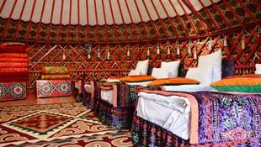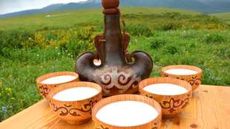

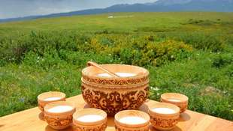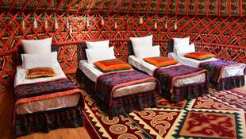

| **GROUP SIZE** |  | **PRICE IN USD/PER PERSON** |  |
| --- | --- | --- | --- |
|  | **MAY - JUNE/cottage** | **JULY/cottage** | **MAY - JULY/yurt stay** |
| 2-3 | 820$ | 775$ | 745$ |
| 4-5 | 740$ | 695$ | 660$ |
| 6-7 | 695$ | 650$ | 610$ |
| 8-9 | 670$ | 635$ | 585$ |
| Supplementary for  single accommodation | 325$ | 280$ | - |

| **PRICE INCLUDES** |  |
| --- | --- |
| Accommodation - twin based | Suusamyr - Baytur complex (4 o/n)   Bishkek - 3* hotel (1 o/n) |
| *Note:* | *Single accommodation is not available in yurt stay. Toilet and shower are located outside the yurt for shared use* |
| Transportation | Comfortable vehicle with a/c for transfers Days 3-4: transportation services are not included. Excursion available for additional cost |
| Meals | Full board: from lunch on Day-1 till breakfast on Day-6 |
| Entrance fees | According to the program |

| **PRICE EXCLUDES** |
| --- |
| International flights |
| Visa support letter/visa/passport registration (if required) |
| Excursions not indicated in the program |
| Guide services |
| Extra services/activities at the complex |

**Contact information:**

[www.travelscruiser.com](http://www.travelscruiser.com)

Phone (24/7): +996 …………., +996 ……….

E-mail: [info@travelscruiser.com](mailto:info@travelscruiser.com)